Bannari Amman Institute of Technology

Sathyamangalam -638 401,Erode District ,Tamil Nadu

DEPARTMENT OF COMPUTER SCIENCE AND ENGINEERING.

WEB PHISHING DETECTION

[(](../../../../../Downloads/Assignment_1.ipynb)**[ASSIGNMENT 1)](../../../../../Downloads/Assignment_1.ipynb)**

DATE : 20-09-2022

PROBLEM : TO ANSWER THE QUESTIONS FOR THE ANSWERS

NAME: VISHAL GUNA

OUTPUT : SCREENSHOTS:

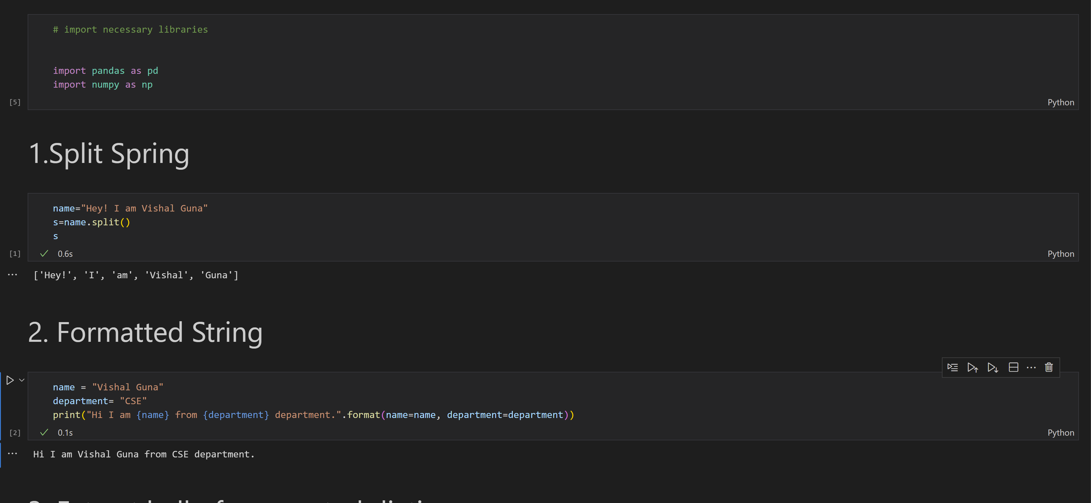

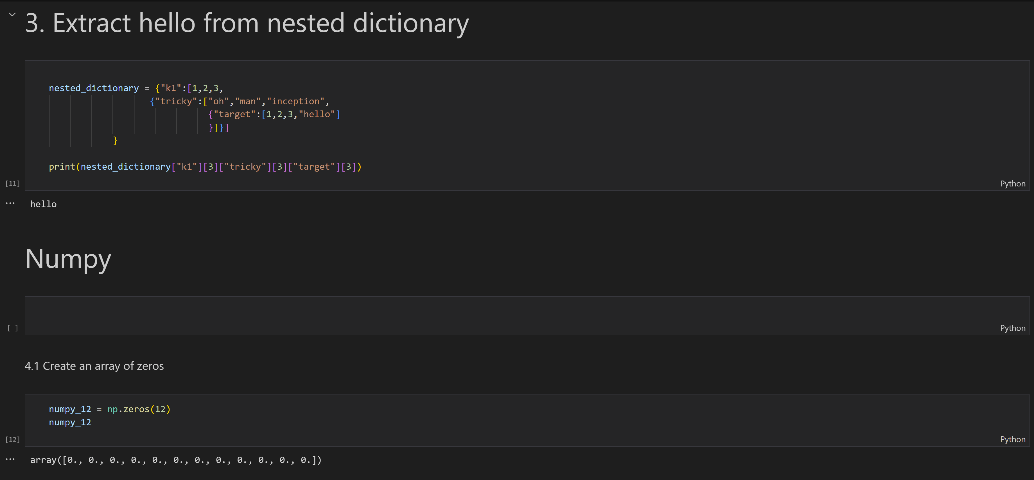

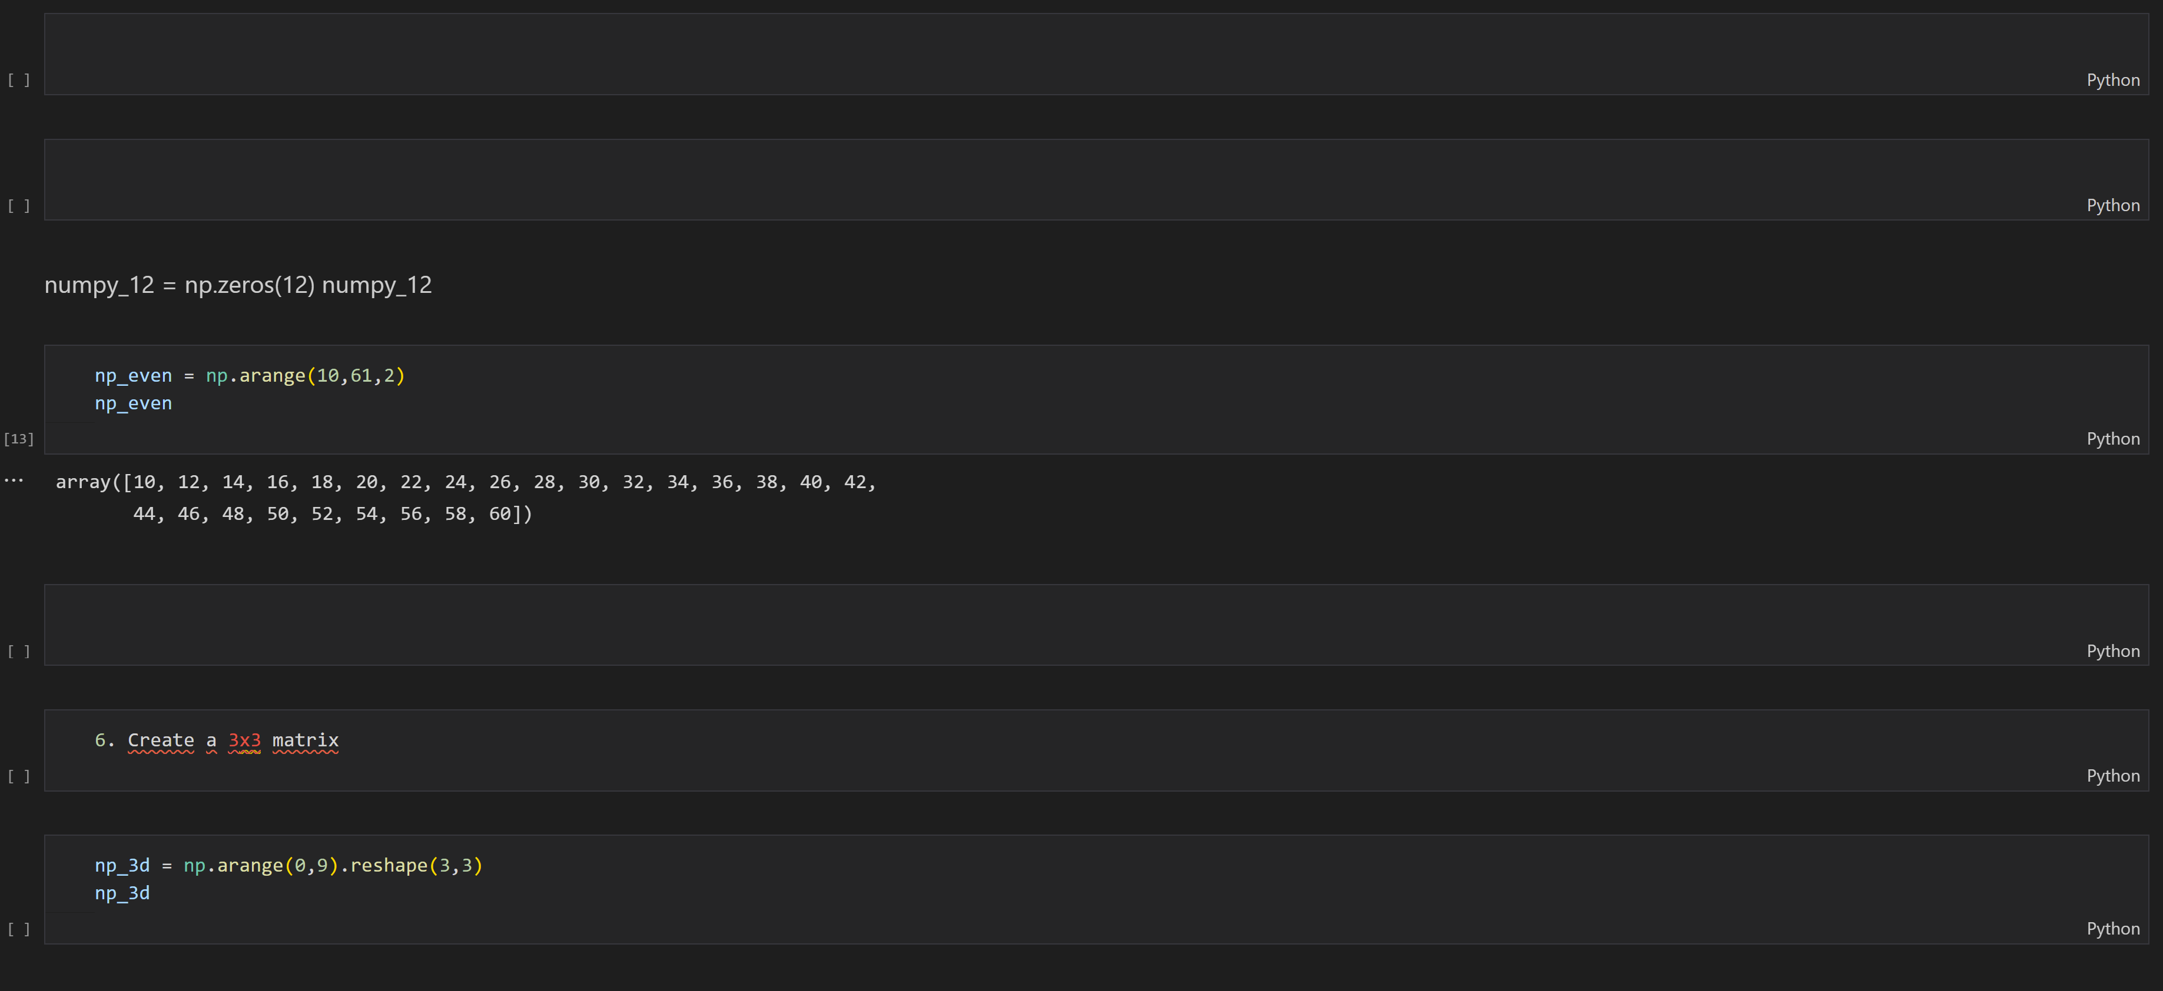

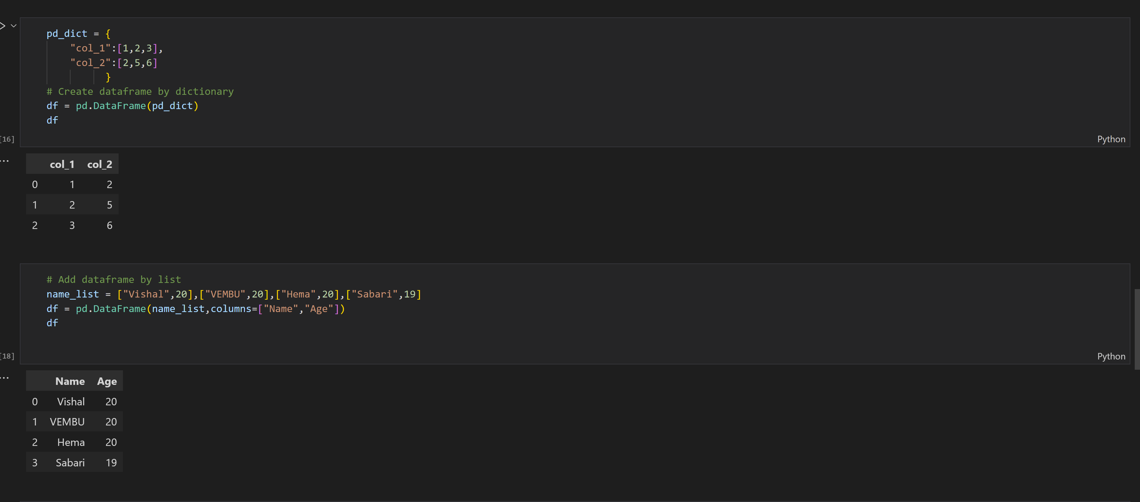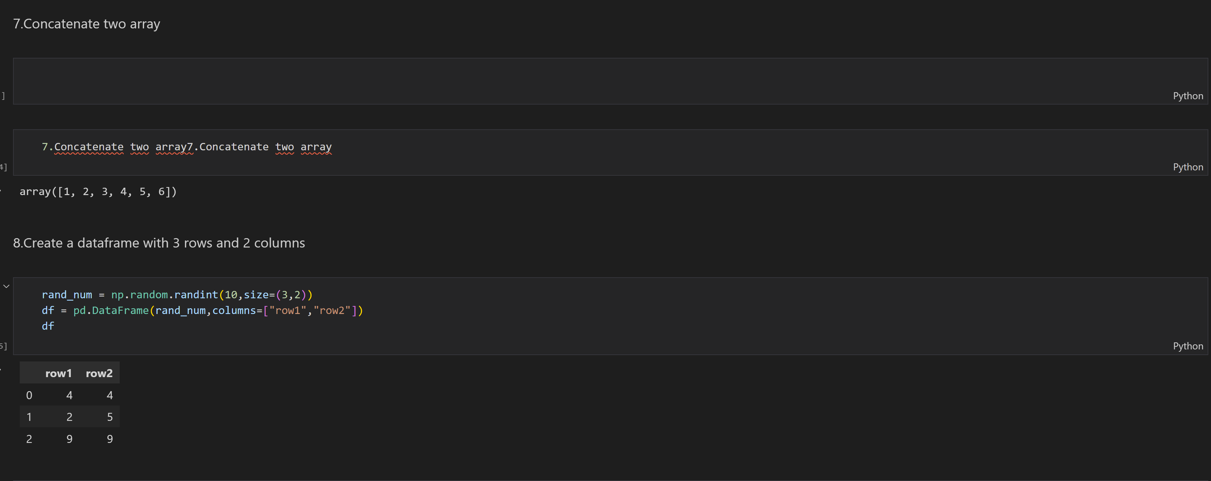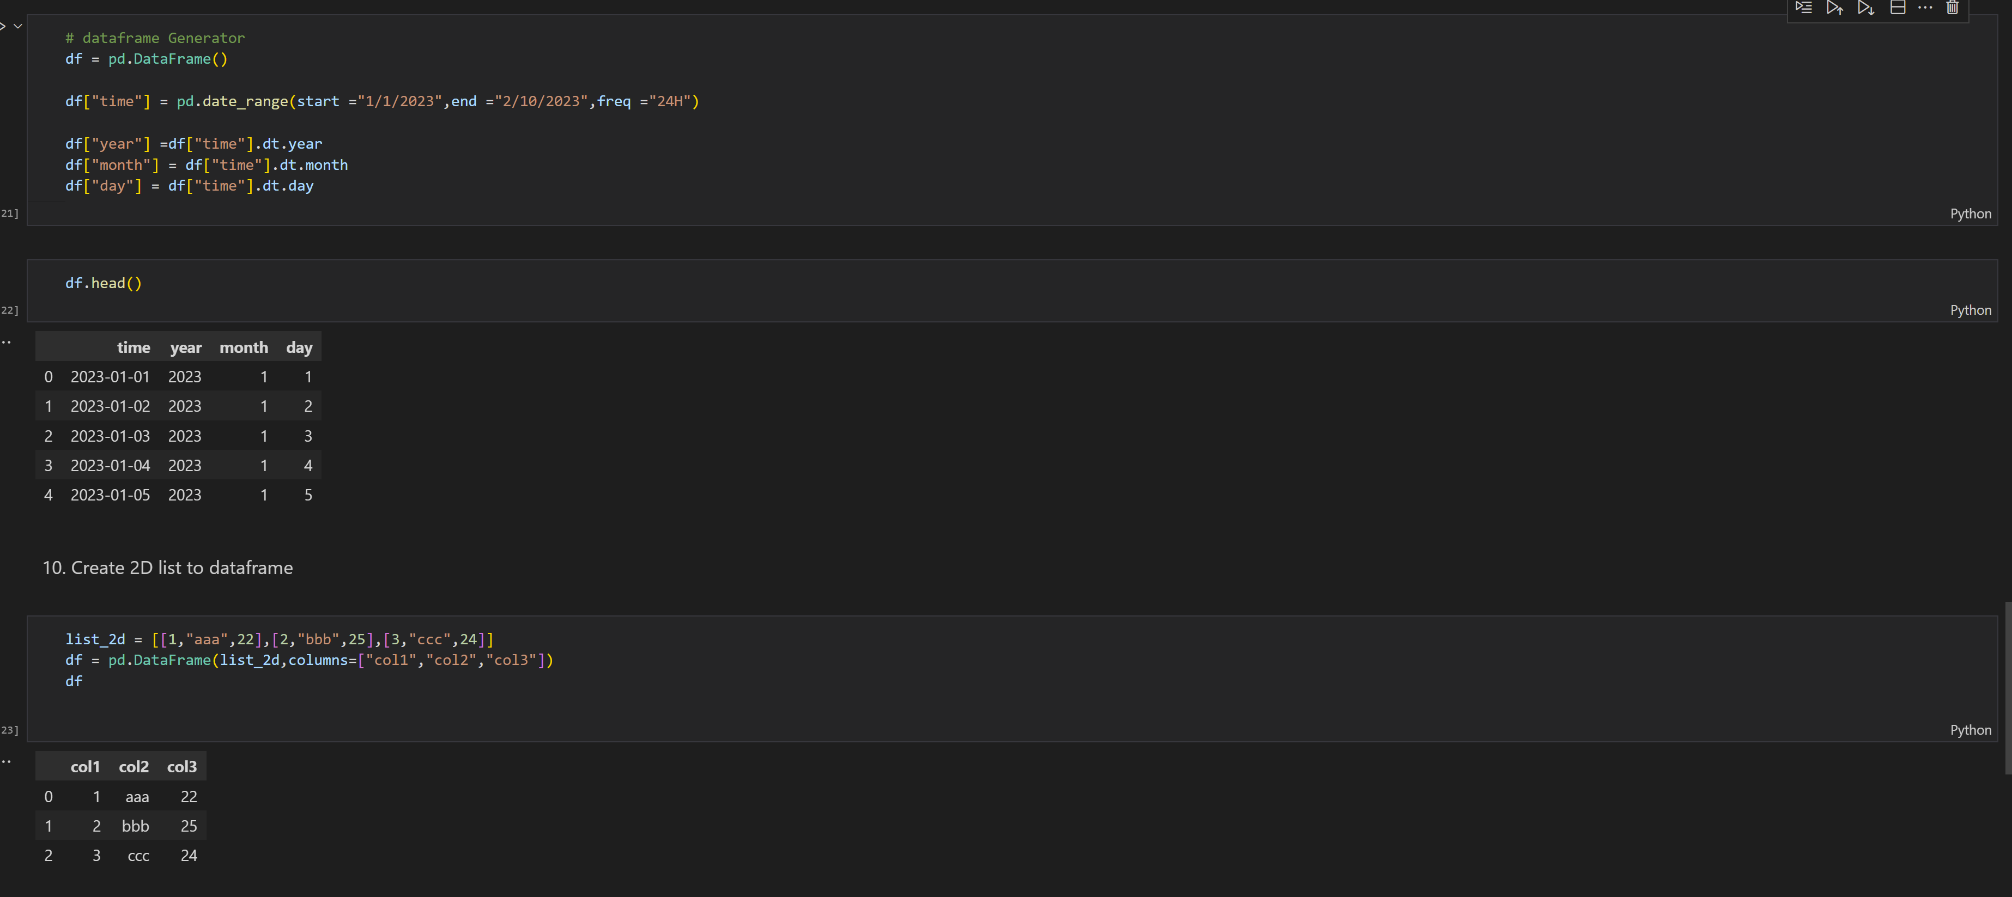

******************************THANKING YOU***********************************